Civil war in Liberia

UNSC Resolution: | 1509
Date of adoption: | 19-Sep-2003
Operative paragraph: | 10
Demand number: | 1509,1011

Sarah-Myriam Martin-Brûlé

Wording of demand

cease all use of child soldiers, cease all human rights violations and atrocities against the Liberia population

List of addressees of the demand

Government of Liberia, Movement for Democracy in Liberia, Liberians United for Reconciliation and Democracy

Short-term compliance

Description of the addressee(s)’ conduct

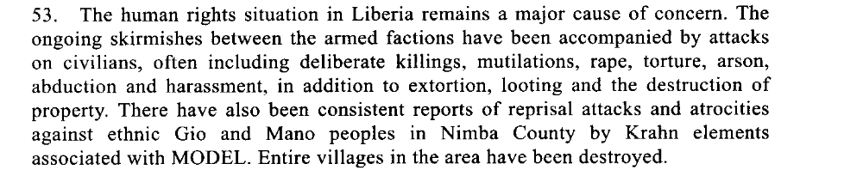
First Progress Report of the Secretary-General on the United Nations Mission in Liberia, 15 December 2003

“As LURD and MODEL each pushed towards Monrovia and Buchanan in the first half
of 2003, these two groups together with government forces stepped up their recruitment
of adults and children. While some children volunteered to join the forces, many others
were forcibly recruited during recruitment drives or following the capturing of new
territory as front lines switched hands. Some children joined particular forces to avenge
violations committed against their family members. Conversely, some children joined
those same forces that committed abuses in their communities to offer protection to
themselves and their families. With the attacks on Monrovia from June through August
2003, more children became involved with the fighting forces both as combatants and
helpers – some driven by the need to help find scarce food and water for their families
Human Rights Watch. 2004. “How to Fight, How to Kill: Child Soldiers in Liberia”, February 2004 Vol. 16, No. 2 (A)
http://www.hrw.org/reports/2004/liberia0204/liberia0204.pdf

Assessment

Short-term compliance
X No or marginal compliance (1) | Medium low compliance (2) | Medium high compliance (3) | Full or almost full compliance (4)

Considerations underlying the assessment

The demand addressees did not cease all use of child soldiers, cease all human rights violations and atrocities against the Liberia population.

Medium-term compliance

Description of the addressee(s)’ conduct
7. Furthermore, there have been reports of harassment of civilians, including extortion and looting by elements of all three armed factions. It is expected that the continuing deployment and consolidation of the UNMIL force throughout the country and progress in the disarmament, demobilization, reintegration and repatriation process will result in a decrease in such incidents. At the same time, UNMIL continued to confiscate weapons, including during checkpoint and searchand- seizure operations.
Second Progress Report of the Secretary-General on the United Nations Mission in Liberia, 22 March 2004, S/2004/229

38. As security has improved and disarmament has progressed, more personnel
from UNMIL, United Nations agencies and non-governmental organizations have
been deployed to the field, resulting in improvements in the delivery of relief aid to
communities that had previously been inaccessible.
Fourth progress report of the Secretary-General on the United Nations Mission in Liberia, 10 September 2004, S/2004/725

Assessment

Medium-term compliance
No or marginal compliance (1) | X Medium low compliance (2) | Medium high compliance (3) | Full or almost full compliance (4)

Considerations underlying the assessment

The demand addressees complied in a minority of incidents yet they did not ceased the use of child soldiers, cease all human rights violations and atrocities against the Liberia population

Depth of demand

Assessment

Level of depth of demand
Low depth of demand (1) | X Medium depth of demand (2) | High depth of demand (3)

Considerations underlying the assessment

The military strategies of the demand addresses often imply the human rights violations. Hence, compliance with this demand might be assessed as having a significant impact on their chances to win power.

Level of confidence about coding decisions

Level of confidence about coding decision
Extremely high | High | X Moderate

Comments to IPI (if any)

